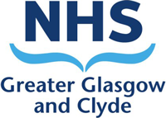

Scottish Paediatric

Cardiac Service

ECHOCARDIOGRAPHY IN
PAEDIATRIC CONGENITAL HEART DISEASE

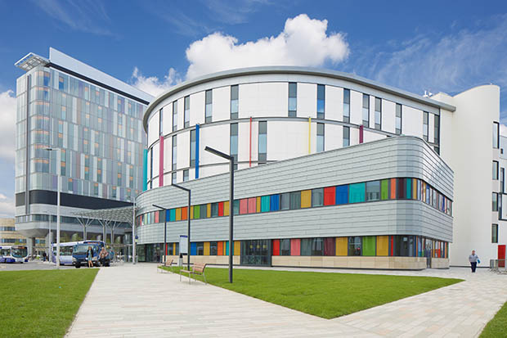

Royal Hospital for Children & Queen Elizabeth University Hospital, Glasgow

www.paediatricecho.co.uk

Overview

The course provides clinically relevant lectures, case studies and hands-on small group tutorial on performing echocardiography with participating volunteer paediatric patients, delivered by consultant paediatric cardiologists, consultant neonatologist with expertise in cardiology and advanced cardiac physiologists with ESC accreditation in congenital heart disease echocardiography. Those with a basic level of experience in Echocardiography will find it much easier to follow. Course lecture handouts will be provided via the course website: http://www.paediatricecho.co.uk/. The course fills quickly so early applications are advised.

Day 1
Wednesday 24th April, 2024

Venue: Teaching and Learning Centre, 1st Floor, Room L1-004b

09.00 – 09.15 Registration

Lectures:

09.15 – 09.20 Maria Ilina Introduction

09.20 – 10:40 Stuart Lilley The Normal Echo Study
Practical Physics & Instrumentation

10:40 – 11.00 ~ Tea/Coffee ~

11.00 – 12.30 Brodie Knight Normal anatomy, segmental analysis &
morphology

12.30 – 13:30 Lindsey Hunter Assessment of ventricular function
Cardiomyopathies & ALCAPA

13:30 – 14:15 ~ Lunch ~

14:15 – 14.45 (TBC) PDA

14.45 – 15.45 Nicholas Martin ASD/PAPVD/TAPVD

15:45 - 16:00 ~ Tea/coffee ~

16.00 – 17.00 Emma Finlay VSD, AVSD

Day 2
Thursday 25th April, 2024

Venue: Teaching and Learning Centre, 1st Floor, Room L1-004b

Lectures:

9.00 – 10:00 Maria Ilina Right-sided obstructive lesions

10:00 – 10:40 (TBC) Univentricular heart and TCPC

10:40 – 11:00 ~ Tea/coffee ~

11:00 – 12:00 (TBC) Left-sided obstructive lesions

12:00 – 13:00 Neil Patel Echocardiography in Neonatology

13:00 – 13:45 ~ Lunch ~

13:45 – 14:15 Ben Smith Coarctation and Ao arch anomalies

14:15 – 15:15 Ben Smith Echocardiography in postoperative follow up

15:15 - 15:30 ~ Tea/coffee ~

15:30 – 16:30 Lesley Armour Complex biventricular heart

16:30 – 17.30 Lindsey Hunter Fetal Echocardiography

17:30 – 18:30 Stuart Lilley Quiz

19.30 Course Dinner: (venue TBC)

Day 3
Friday 26th April, 2024

Venue: Teaching and Learning Centre, Clinical Skills Area

Practical Studies:

09:00 – 10:45 M-mode, 2D echo and Doppler. Image acquisition and optimisation

10:45 – 11:00 ~ Tea/coffee ~

11:00 – 13:00 Normal study

HeartWorks

13:00 – 13:45 ~ Lunch ~

13:45 – 15:30 “Simple” congenital lesions (ASD, VSD, AS, PS, PDA)

HeartWorks

15:30 – 15:50 ~ Tea/coffee ~

15:50 – 17:30 “Moderate” (ToF, TGA) and “complex” (DORV, complex TGA, common arterial trunk, PA/VSD, PA/IVS, CCTGA, Ebstein anomaly) biventricular congenital cardiac lesions

3D models

Day 4
Saturday 27th April, 2024

Venue: Teaching and Learning Centre, Clinical Skills Area

Practical studies:

10.00 –12:30 Simple, Moderate, Complex biventricular and univentricular hearts

HeartWorks

3D models

Please complete and hand in course evaluation forms, then receive password to download handouts

~ End of Course ~

COURSE FACULTY

Ms Lesley Armour, Paediatric Cardiac Physiologist
RHC Glasgow

Dr Richard Ferguson, Consultant Paediatric Cardiologist
RHCYP, Edinburgh and RHC Glasgow

Ms Emma Finlay, Lead Cardiac Physiologist
RHC Glasgow

Dr Pankaj Gupta, Consultant Paediatric Cardiologist
RHC Glasgow

Dr Amanda Hunter, Consultant Adult Congenital Cardiologist
Golden Jubilee National Hospital, Glasgow

Dr Lindsey Hunter, Consultant Paediatric Cardiologist

RHC Glasgow

Dr Maria Ilina, Consultant Paediatric Cardiologist
RHC Glasgow

Dr Brodie Knight, Consultant Paediatric Cardiologist
RHC Glasgow

Mr Stuart Lilley, Consultant Cardiac Physiologist
RHC Glasgow

Ms Lynsey McIntyre, Senior Cardiac Physiologist
RHC Glasgow

Mr Nicholas Martin, Cardiac Physiologist
RHC Glasgow

Dr Patrick Noonan, Consultant Paediatric Cardiologist
RHC Glasgow

Dr Neil Patel, Consultant Neonatologist
RHC Glasgow

Dr Benjamin Smith, Consultant Paediatric Cardiologist
RHC Glasgow

Course Co-Directors: Lynsey McIntyre, Lesley Armour, Maria Ilina

Course Administrator: Glasgow Children’s Hospital Charity

Course website www.paediatricecho.co.uk

This course would not be possible without the generous support from:

GE Healthcare

HeartWorks

