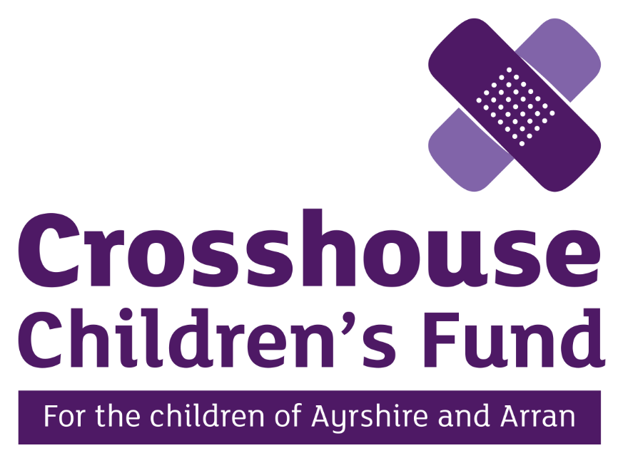
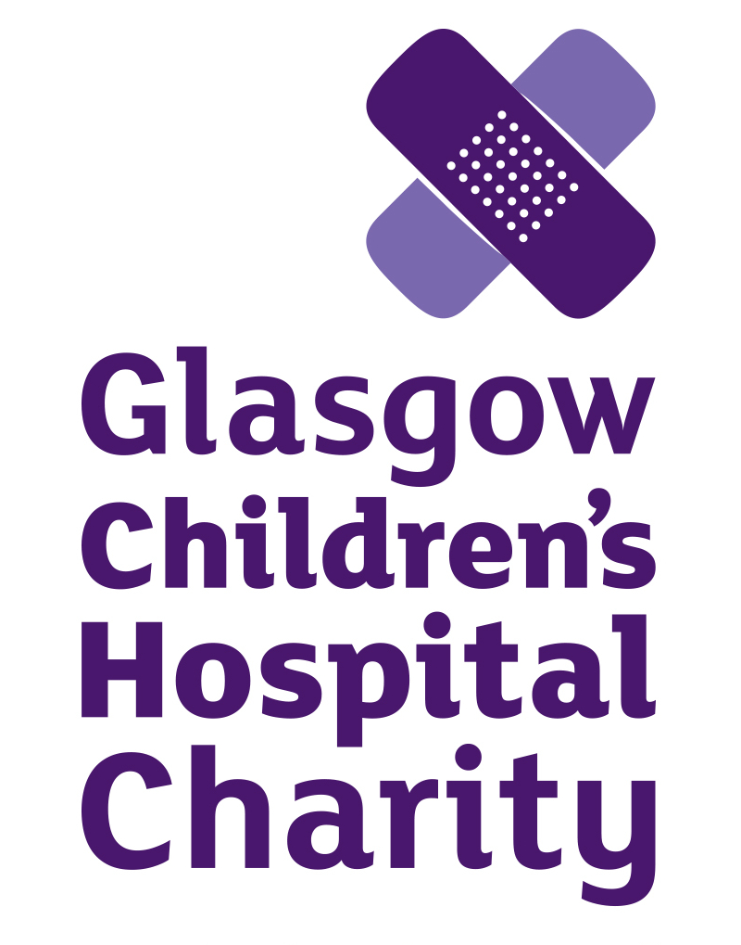
Job Description

Job Title | Community Fundraising Manager
Location | Hybrid –University Hospital Crosshouse, Kilmarnock/ Head Office, Paisley/ Home based
Reporting To | Head of Partnerships & Business Development
Salary | £29,000 - £35,000 DOE
Hours | 35 hours  The Charity will consider alternative flexible arrangements where required
Status | Full time
Holidays | 25 days plus 10 bank holidays, plus additional long service days
Benefits | As a compassionate organisation we care about our staff and have a range of employee benefits that make Crosshouse Children’s Fund a great place to work – please see our range of employee benefits here

Crosshouse Children’s Fund

Our Vision and Values

We raise funds to help those who tirelessly care for and nurture young lives at their most vulnerable; to invest in equipment, research and the continued improvement of facilities and services for children and families in hospital. Our core values guide our work on a daily basis:

Pride: we care. | We are proud ambassadors of the charity, and will carry out our work with conviction. It’s not just a job; it’s our privilege to be part of this special community of supporters, children and families.
Enthusiasm: we are inspired. | We will enthusiastically approach each new opportunity, inspired by the resilience, hope and commitment of our supporters, patients and families. We are always looking up.
Determination: we are all in. | We are determined to give our all, because we are dedicated to the children, families and staff we support. They deserve our best work.
Unity: we are one team. | We respect and encourage each other. We can make an extraordinary impact when we work together with our colleagues, our supporters and the NHS.
Integrity: we do what we say we’ll do. | We promise to be honest, professional and respectful. We will never compromise the charity’s reputation or our values, and will always act in the best interests of those we support.

Job Purpose

Established by Glasgow Children’s Hospital Charity in 2019, Crosshouse Children’s Fund raises money for the children’s wards, maternity unit and neonatal unit located at University Hospital Crosshouse, as well as supporting community services throughout Ayrshire & Arran.

The charity aims to enhance hospital experiences for patients and families by providing enhanced equipment and support services that can help alleviate the worries of a hospital visit.

Our Community Fundraising Manager is responsible for developing and implementing community fundraising campaigns and events to grow the charity’s income, and build value added relationships with donors, fundraisers and volunteers.

You will lead the development of fundraising campaigns for the charity’s key community and event activities, including:

- Education and youth;
- Running and active events;
- Third party events;
- Challenge events;
- Community collections;
- Supporter led fundraising;
- Crosshouse Children’s Fund events.

We are looking for an enthusiastic, creative individual who can work methodically and manage multiple projects simultaneously.

Our ideal candidate will have experience in a fundraising environment, a record of accomplishment of delivering against ambitious income targets, and excellent relationship management skills.

Reports to: Head of Partnerships & Business Development

Key Responsibilities

Community Fundraising Campaigns & Events

- Develop and implement campaigns that achieve financial and engagement targets for key activities and supporter groups, including:
  - Education and youth;
  - Running and active events;
  - Third party events;
  - Challenge events;
  - Community collections;
  - Supporter led fundraising
  - Crosshouse Children’s Fund events

- Work diligently to ensure all fundraising campaigns comply with regulations and best practice;
- Introduce new, creative campaigns and fundraising ideas;
- Ensure every supporter receives excellent support;
- Create and manage clear supporter journeys;
- Create, plan and deliver fundraising events aimed at different audiences;
- Work closely with the GCHC Fundraising Campaigns Team on shared projects

Engagement

- Nurture strong relationships with supporters to extend their support beyond the first event/ activity;
- Develop engagement programmes to increase the long-term value of supporters;
- Create added-value opportunities for supporters to ensure their experience with the charity is memorable;
- Identify trends and opportunities for existing supporters through analysis of our supporter data;
- Work closely with the Fundraising & Marketing team to share the inspiring stories of our fundraisers.

Additional Responsibilities

- To be committed and adhere to Crosshouse Children’s Fund vision, mission and values.
- To actively consider professional development and determine training needs.
- To maintain and develop good working relationships with volunteers working with Crosshouse Children’s Fund and Glasgow Children’s Hospital Charity
- To provide cover if required to the Fundraising Hub located at the Royal Hospital for Children, Glasgow.
- To maintain and develop good working relationships with other members of the wider organisation.
- Any other duties required by the Head of Partnerships & Business Development

Person Specification

Essential | Desirable
3+ years working in a fundraising environment | Knowledge of the third sector in Scotland
Experience building relationships with donors/ fundraisers | Experience working with a fundraising CRM/ database
Creativity | Experience working with volunteers
Excellent communication skills | Experience of fundraising in Ayrshire and Arran
Experience working with budgets
Strong planning and project management skills
A Disclosure Scotland check will be carried out under the Protection of Vulnerable Groups (PVG) Scheme – it is therefore essential that any criminal convictions are disclosed
Driving licence and access to a car, and able to drive the charity’s small van on occasion (training provided)

