
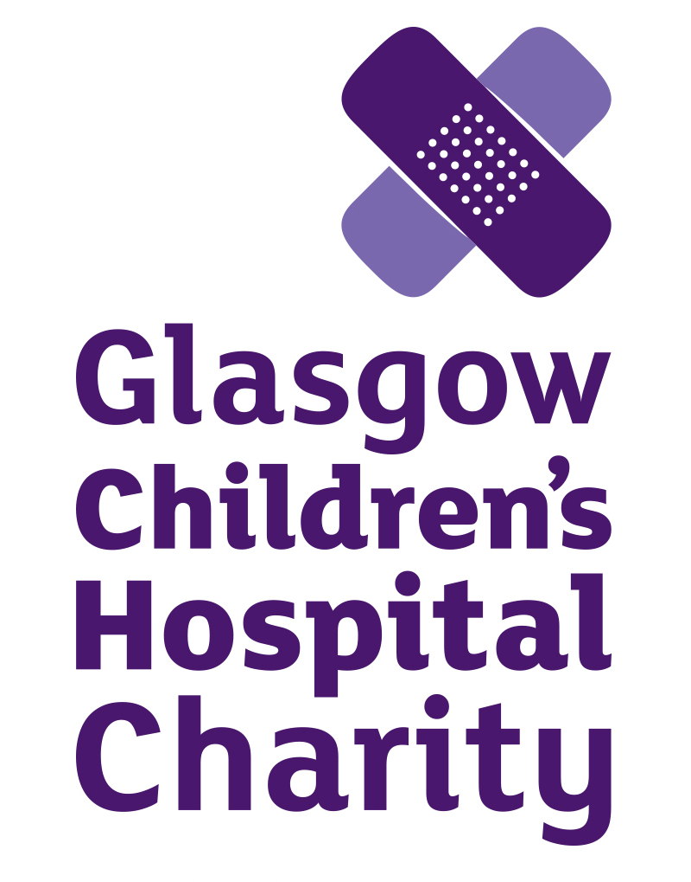
Job Description

Job Title | Marketing and Campaigns Manager
Location | Hybrid – Paisley office / Royal Hospital for Children / working from home
Reporting To | Head of Marketing and Engagement
Salary | £29,000 - £35,000 DOE
Hours | 35 hours  The Charity will consider alternative flexible arrangements where required
Status | Full time
Holidays | 25 days plus 10 bank holidays, plus additional long service days
Benefits | As a compassionate organisation we care about our staff and have a range of employee benefits that make Glasgow Children’s Hospital Charity a great place to work – please see our range of employee benefits here

Glasgow Children’s Hospital Charity

Our Vision and Values

We raise funds to help those who tirelessly care for and nurture young lives at their most vulnerable; to invest in equipment, research and the continued improvement of facilities and services for children and families in hospital. Our core values guide our work on a daily basis:

Pride: we care. | We are proud ambassadors of the charity, and will carry out our work with conviction. It’s not just a job; it’s our privilege to be part of this special community of supporters, children and families.
Enthusiasm: we are inspired. | We will enthusiastically approach each new opportunity, inspired by the resilience, hope and commitment of our supporters, patients and families. We are always looking up.
Determination: we are all in. | We are determined to give our all, because we are dedicated to the children, families and staff we support. They deserve our best work.
Unity: we are one team. | We respect and encourage each other. We can make an extraordinary impact when we work together with our colleagues, our supporters and the NHS.
Integrity: we do what we say we’ll do. | We promise to be honest, professional and respectful. We will never compromise the charity’s reputation or our values, and will always act in the best interests of those we support.

Job Purpose

Our Marketing and Campaigns Manager is responsible for inspiring people to support Glasgow Children’s Hospital Charity. The role involves sharing the stories of a remarkable group of people – the children, families and NHS staff at the hospital, and the dedicated fundraisers and volunteers who generously give their time and money to support them.

You will develop and manage creative marketing and fundraising campaigns, manage a team of two, and contribute to the growth of the charity together with other managers. You will be responsible for leading the development and implementation of the charity’s marketing strategy, and support the Head of Marketing and Engagement with the charity’s individual giving strategy.

Our ideal candidate will be experienced in managing campaigns across direct, digital and social channels, with a strong understanding of all principles of marketing. You will be an enthusiastic and encouraging manager, with a drive to achieve ambitious targets.

Reports to: Head of Marketing and Engagement
Line management: Social Media and Engagement Co-Ordinator; Marketing and Communications Officer.

Key Responsibilities

Marketing

- Coach and manage our marketing team of two, providing guidance, encouragement and development opportunities;
- Manage GCHC’s marketing strategy, incorporating all elements of marketing – including design, digital, film, content, social media, PR and copywriting;
- Develop and implement GCHC’s social media strategy, maximising conversion and engagement across audiences and channels;
- Manage the content strategy, ensuring we tell stories that resonate with our audiences and create value, while always demonstrating sensitivity, consideration and kindness to the families whose stories we are sharing;
- Manage the charity’s PR activities with key journalists, influencers and other relevant stakeholders;
- Support all teams with marketing plans to promote events and campaigns;
- Work closely with all teams to build engagement with key audiences at the hospital, in the community and with partners;
- Manage the charity’s marketing responsibilities for Crosshouse Children’s Fund, our subsidiary charity;
- Support the Marketing & Engagement team’s out of hours rota;
- Any other relevant duties as may be required by the Head of Marketing and Engagement

Campaigns
- Work with the Head of Marketing and Engagement to develop and implement new donor acquisition and retention campaigns;
- Work with the Fundraising Manager and wider team to develop campaigns for key income-generating activities, including schools, running events and challenges;
- Introduce and pilot new opportunities based on an awareness of emerging sector trends;
- Combine a data-driven approach with creativity to explore new opportunities within our existing supporter-base.

Additional Responsibilities

- To be committed and adhere to Glasgow Children’s Hospital Charity’s vision, mission and values.
- To actively consider professional development and determine training needs.
- To maintain and develop good working relationships with volunteers working with Glasgow Children’s Hospital Charity.
- To provide cover if required to the Fundraising Hub located at the Royal Hospital for Children, Glasgow.
- To maintain and develop good working relationships with other members of the wider organisation including the Fundraising Team, the Finance Team, the Volunteer Team and the wider organisation.
- Any other duties required by the Head of Marketing and Engagement

Person Specification

Essential | Desirable
4+ years working in marketing or fundraising | Knowledge of the third sector in Scotland
Experience of social, digital and direct marketing | Experience working or volunteering with a charity
Creativity | Experience managing a small team
Excellent communication skills | Project management experience
Strong relationship-building skills | Driving licence and access to a car
A Disclosure Scotland check will be carried out under the Protection of Vulnerable Groups (PVG) Scheme – it is therefore essential that any criminal convictions are disclosed

